LAB 4

Ex:3

AM.EN.U4CSE21432

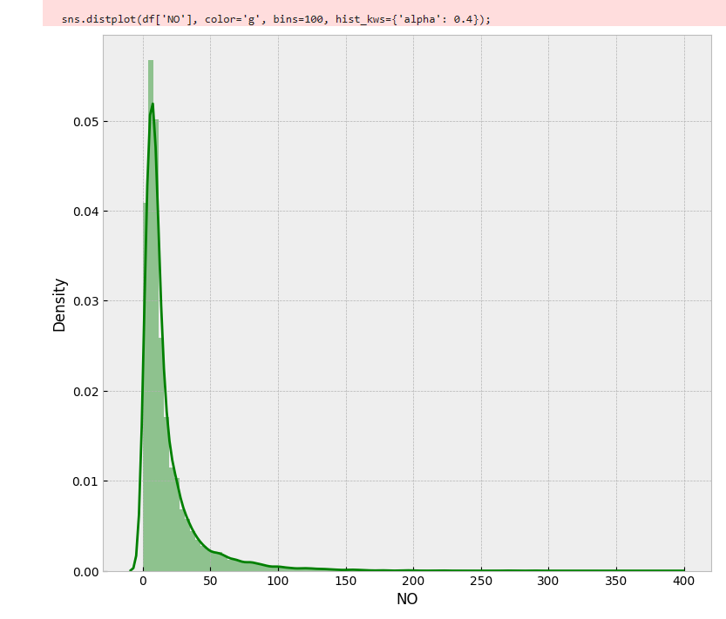

This graph shows the density of the variable(column) NO. We can see that it is distributed in the range of 0-100.

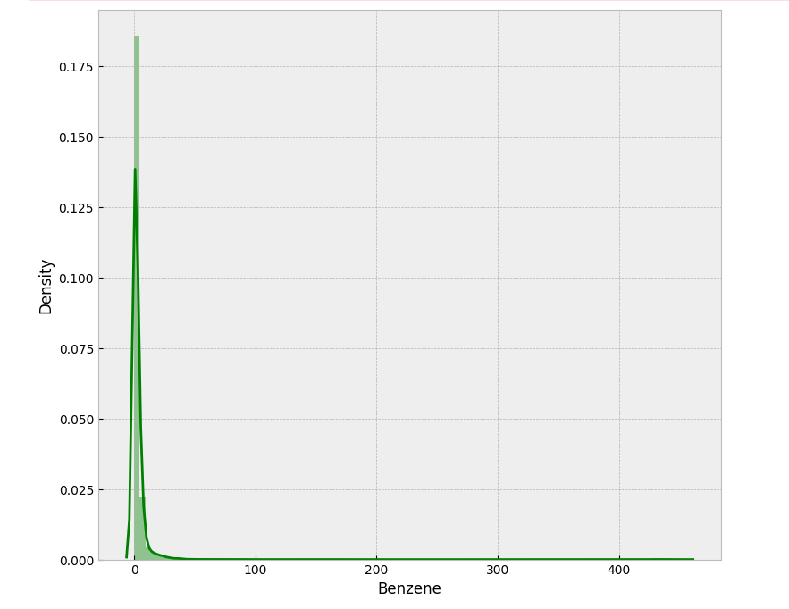

This graph shows the density of the variable(column) Benzene. We can see that it is distributed in the range of 0-20(approx.).

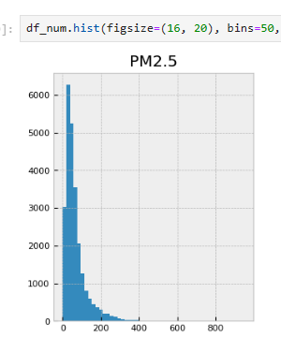

This is histogram plot of PM2.5 variable(column). It ranges from 0-300.(approx.)

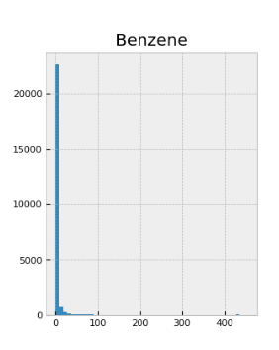

This is histogram plot of Benzenne variable(column). It ranges from 0-50.(approx.)

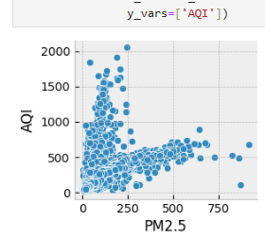

This is plot of correlation between PM2.5 AND AQI. We can observe that they are strongly correlated. Correlation a>0.5 is considered as strongly correlated.

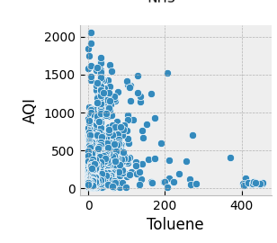

This is plot of correlation between Tolune AND AQI. We can observe that they are NOT strongly correlated. Correlation a<0.5 is considered as strongly correlated.

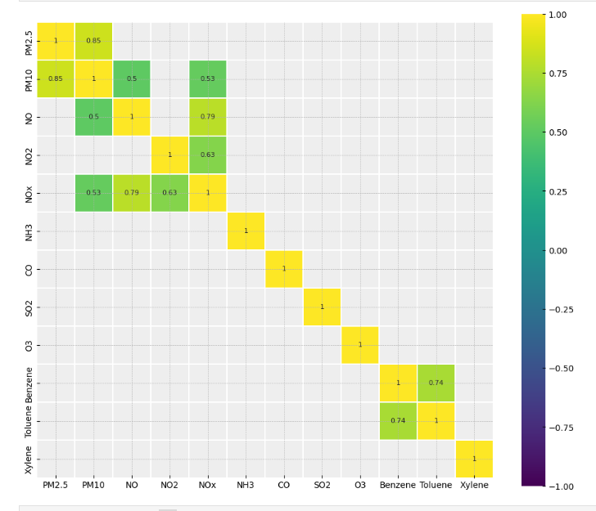

This is heat map. This represents date in matrix format with different colours. Correlation matrix is represented using heat map.

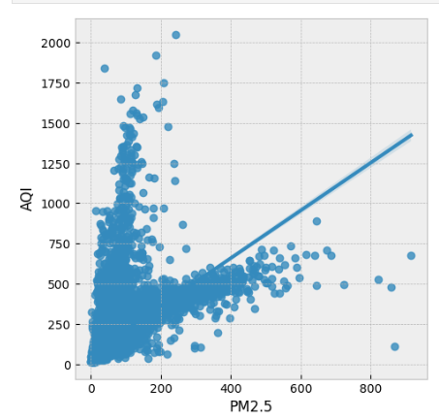

This is graph between two strongly related data. Here We can see that data points are clustered representing the strong relation.

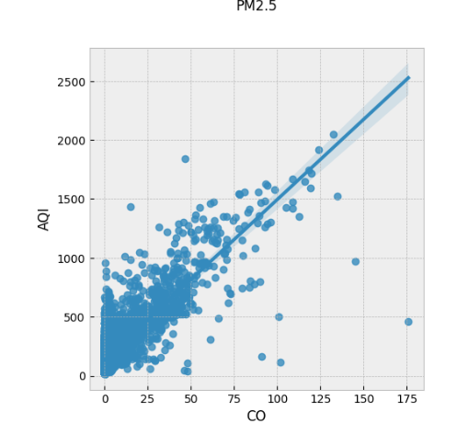

This is graph between two strongly related data. Here We can see that data points are around the line representing the strong relation.

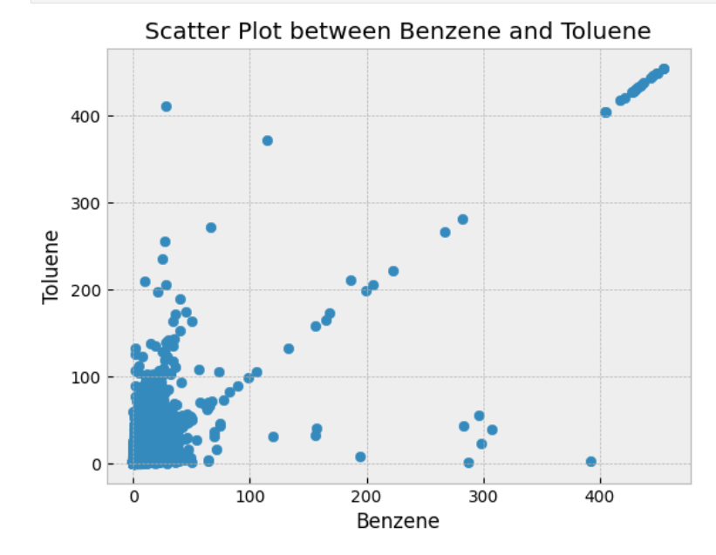

This is just a scatter plot between two data colums. Here each data point is plotted.